Template Input Fields

→ Every template needs to have an option for choosing the colour of the templates

**Template 1- Mobile 3:**

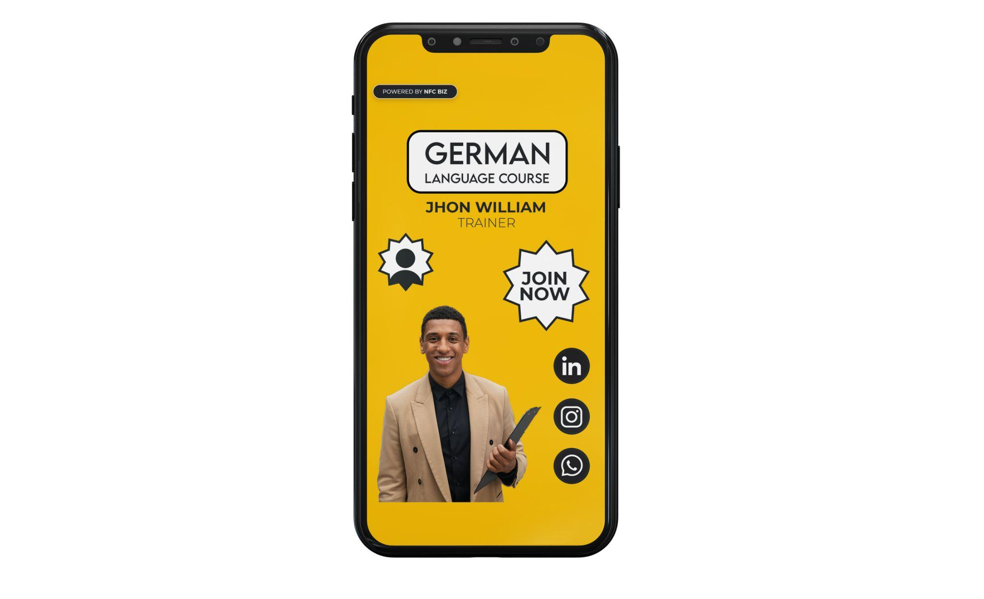

Form Fields

Title:( Heading )

Name and Occupation:

Contact Information:

→ Email:

→ Phone no

→ Address

Link to your website:

Image - Upload your image

Social media links:

→ Facebook, LinkedIn, Instagram, Youtube, Whatsapp, Twitter

**Template 2 - Mobile 10: (CV/ Portfolio)**

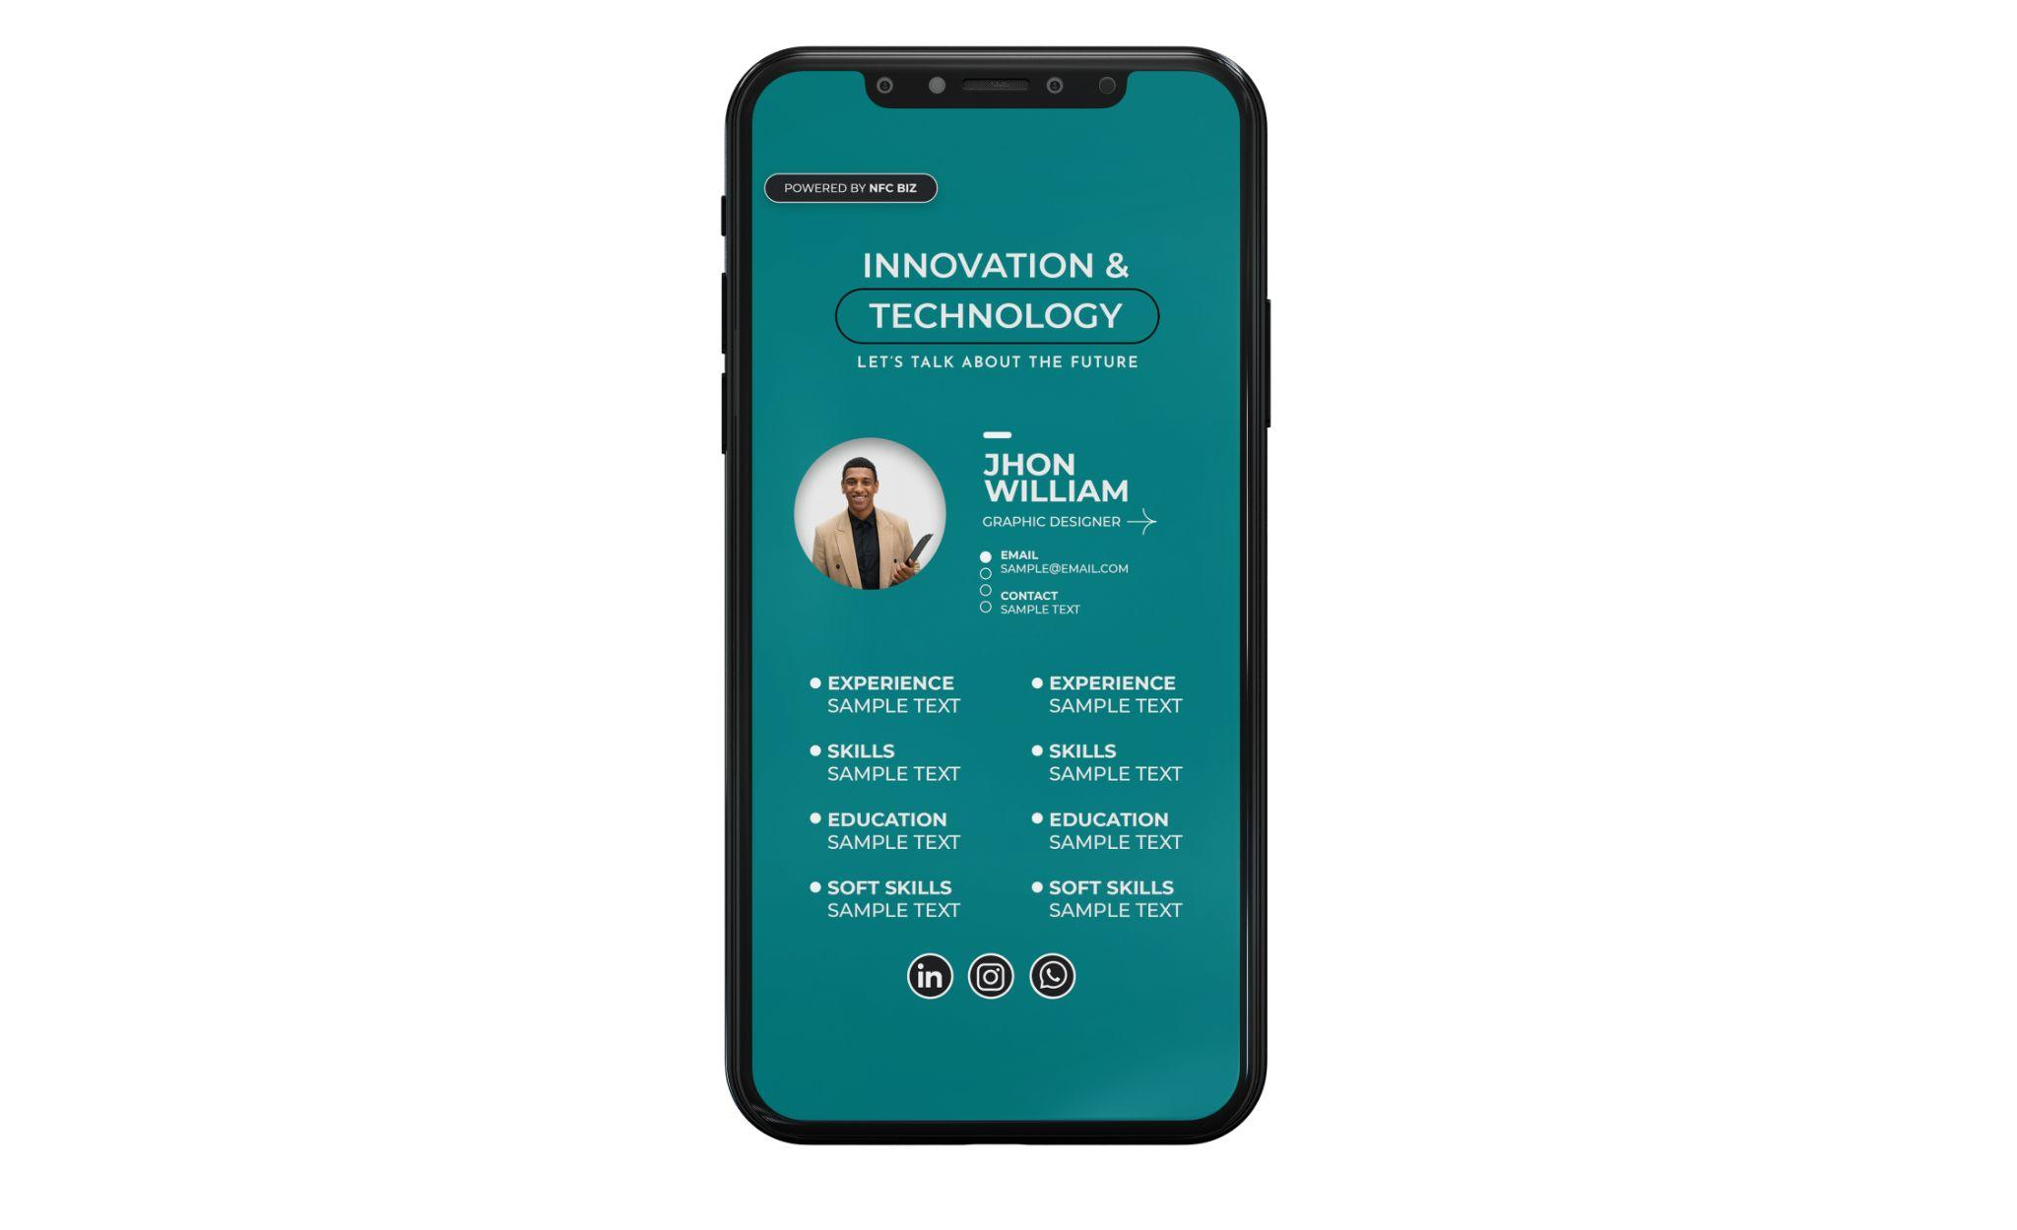

Title - ( Heading )

Subheading ( Additional Text )

Upload picture

Name

Occupation

Email

Location

Contact information

Experience 1:

Experience 2:

Skill 1:

Skill 2:

Education 1:

Education 2:

Soft Skills 1:

Soft Skills 2:

( Experience, Education, Soft Skills can be n number i,e., suited according to the need of the customer )

Social media links:

Instagram

Linked In

WhatsApp

Facebook

YouTube

TikTok

Twitter

**Mobile 8:**

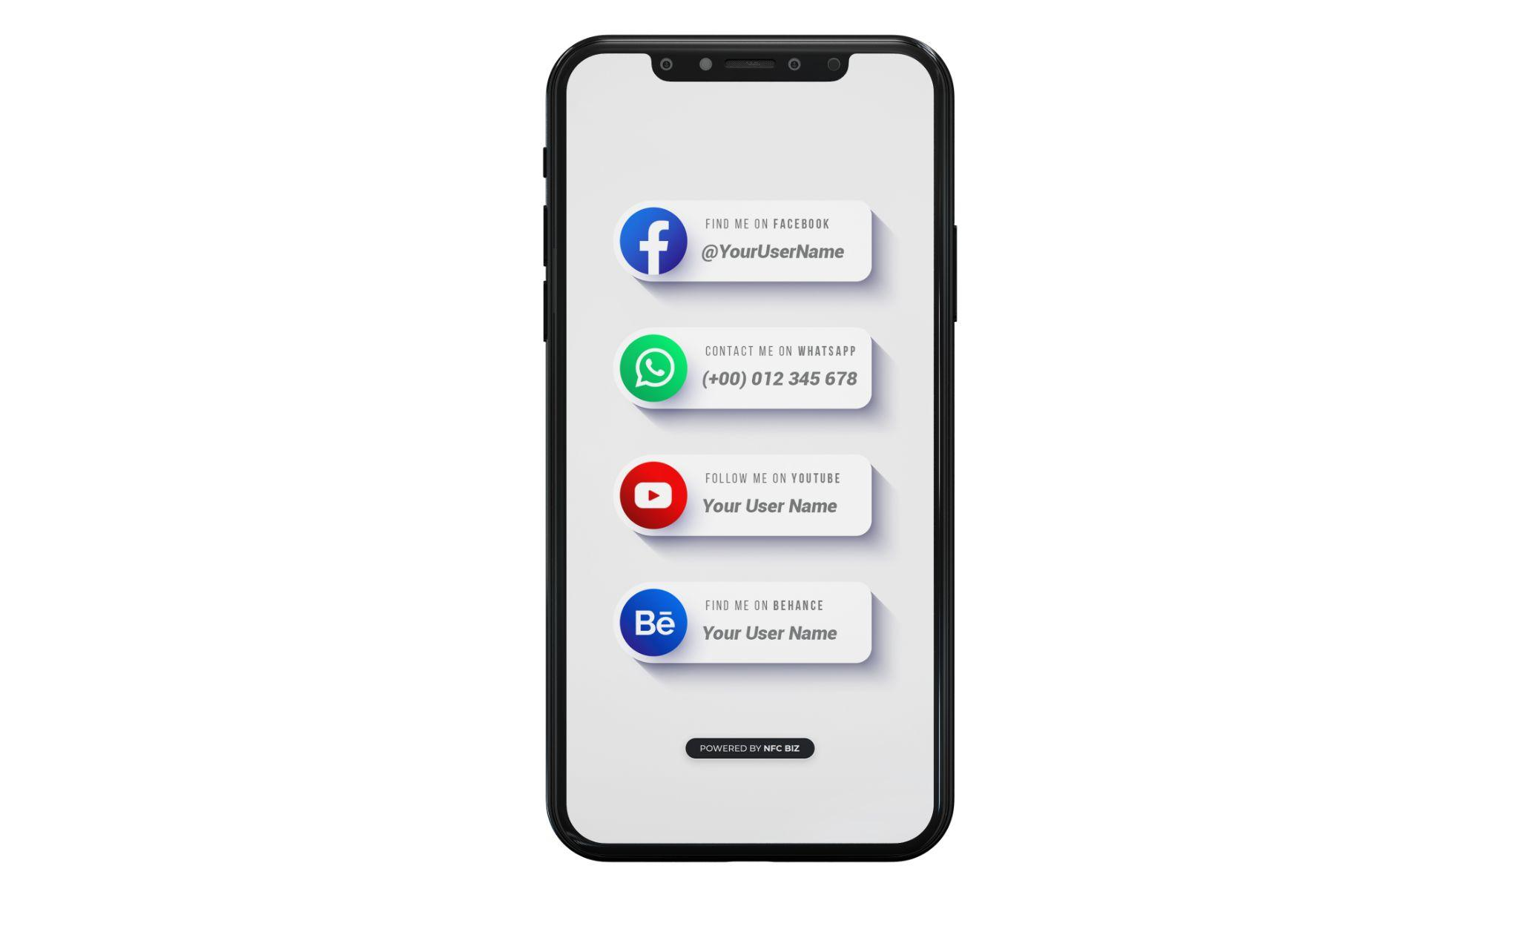

Title - Heading

All the social media links

Instagram

Linked In

WhatsApp

Facebook

YouTube

TikTok

Twitter

**Mobile 6:**

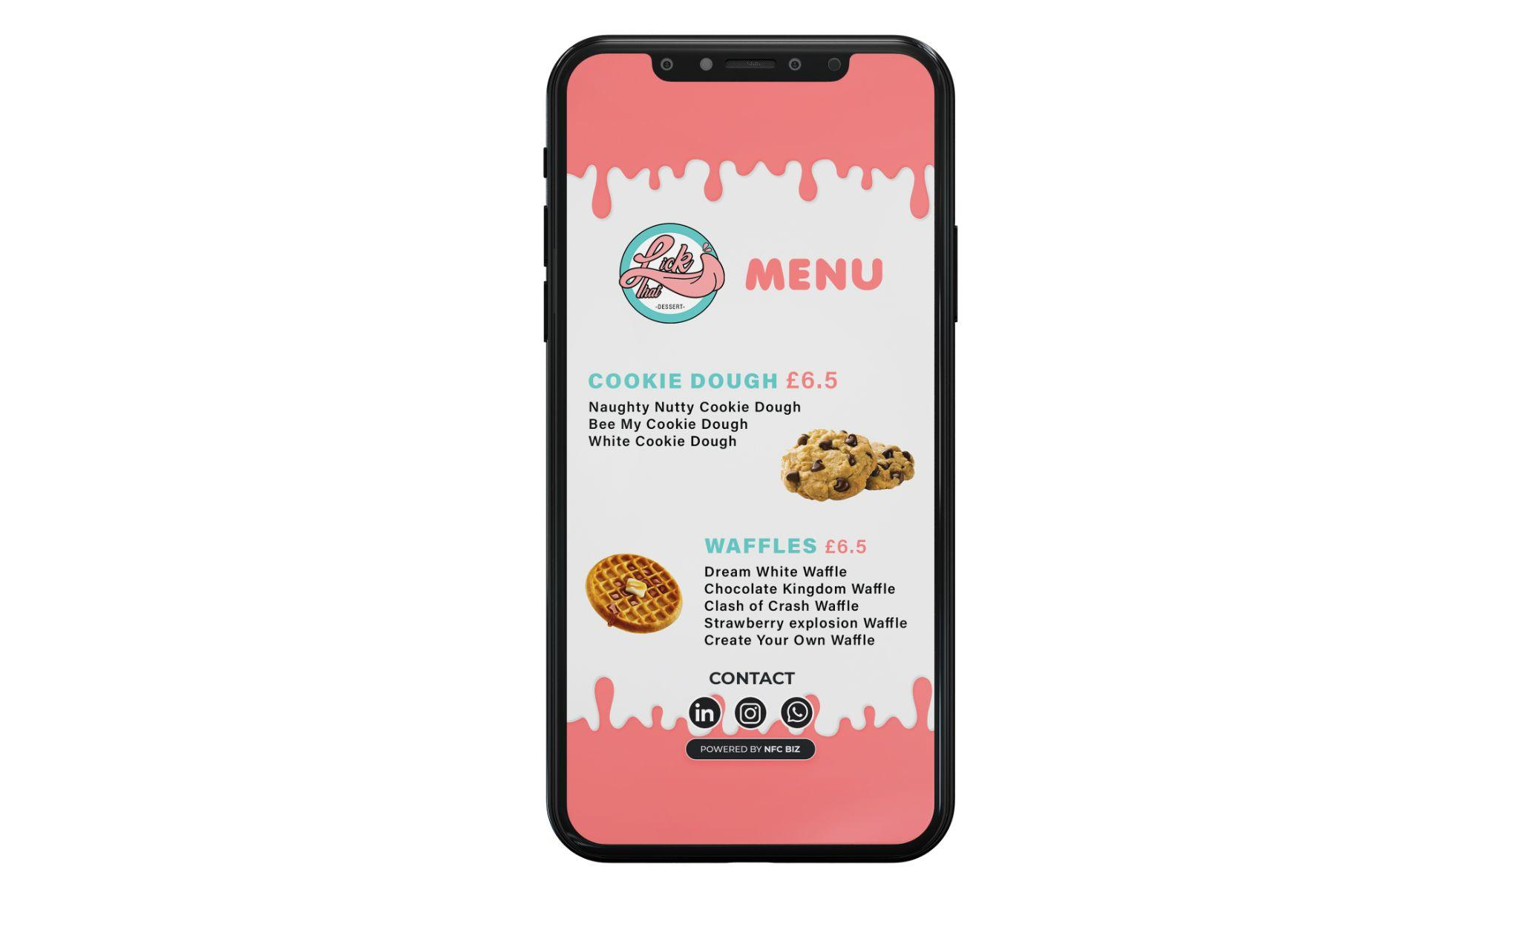

Menu - Title

Logo - Upload image

( More items can be added )

Item 1 - Name, price, image and description

Item 2 - Name, price, image and description

Social Media Links

Instagram

Linked In

WhatsApp

Facebook

YouTube

TikTok

Twitter

**Mobile 7: (MENUs)**

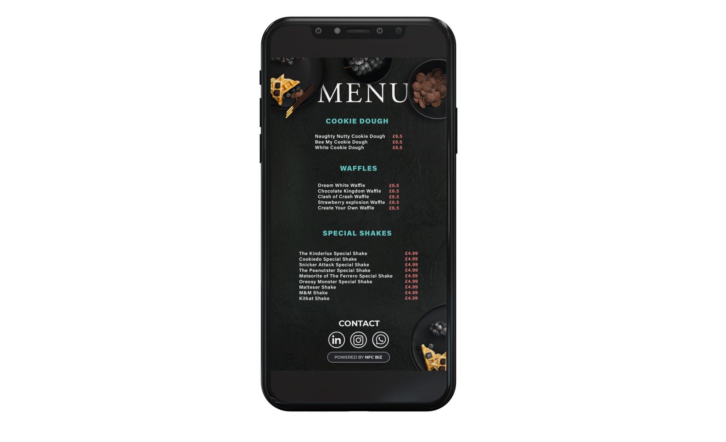

Title - Menu

Background image - Upload image

( The user should be able to add n number of categories to the list )

Item Category 1- Title

Item 1 - Description & Price

Item 2 - Description & Price

Item 3 - Description & Price

Item Category 2- Title

Item 1 - Description & Price

Item 2 - Description & Price

Item 3 - Description & Price

Item 4 - Description & Price

Item 5 - Description & Price

Item Category 3- Title

Item 1 - Description & Price

Item 2 - Description & Price

Item 3 - Description & Price

Item 4 - Description & Price

Item 5 - Description & Price

Item 6 - Description & Price

Item 7 - Description & Price

Item 8 - Description & Price

Social Media Links

Instagram

Linked In

WhatsApp

Facebook

YouTube

TikTok

Twitter

**Phone Size 9: (Shopping catalogue)**

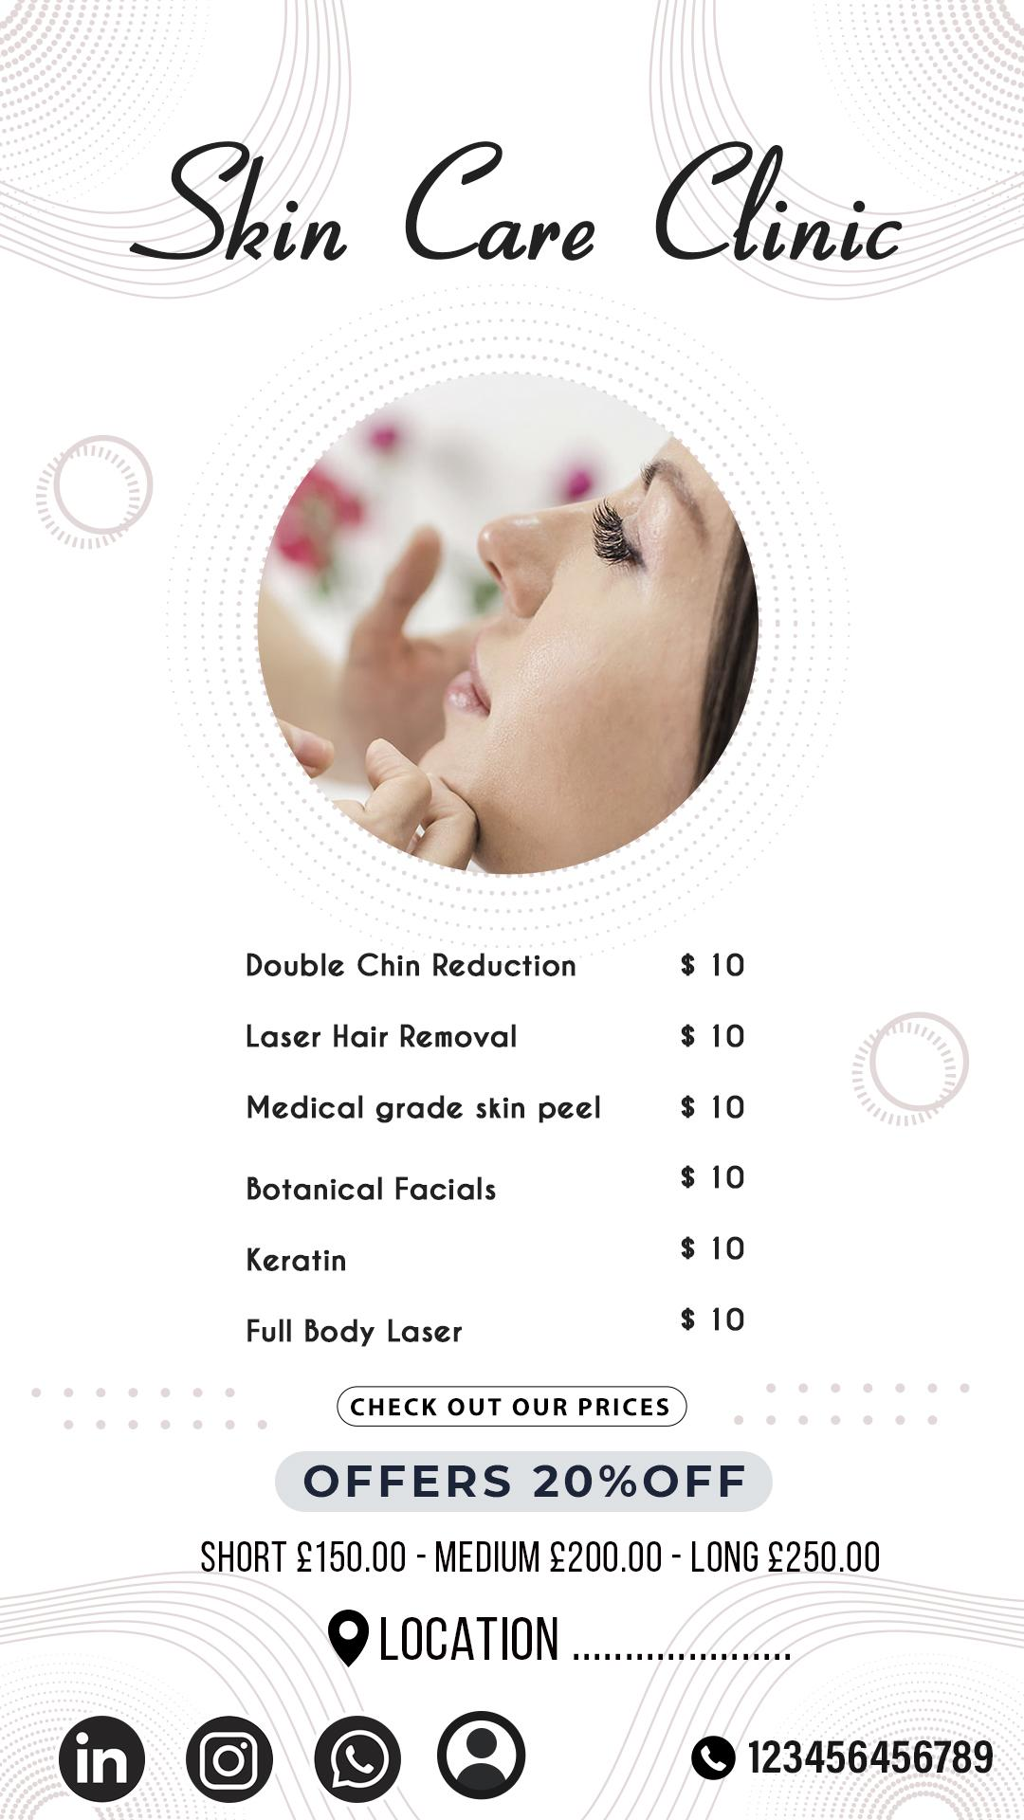

Background image - Upload image

Title ( Heading )

Image - Upload image

( More items can be added )

Item 1 - Name & Price

Item 2 - Name & Price

Item 3 - Name & Price

Item 4 - Name & Price

Item 5 - Name & Price

Item 6 - Name & Price

Link - Link text, Link

Offer - Heading

Offer - Description

Location - Address

Social Media Links

Instagram

Linked In

WhatsApp

Facebook

YouTube

TikTok

Twitter

Contact information -

→ Name

→ Email

→ Phone number

→ Address

Contact number

**Phone Size 10:**

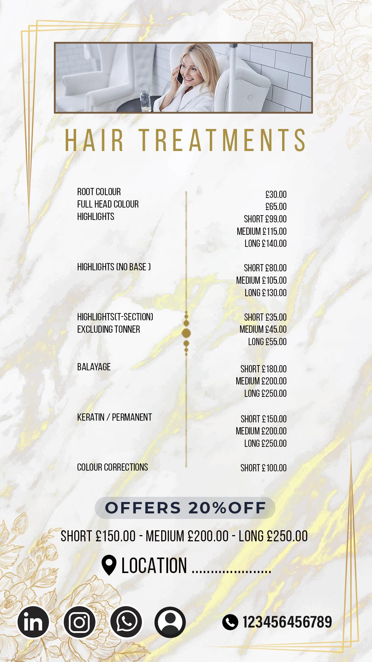

Background Image - Upload Image

Title - Heading

Item 1 - Name & Price

Item 2 - Name & Price

Item 3 - Name & Price ( If the user selects variation in the items then it should be displayed as in the template and additional input fields should be created according to the requirement of the customer )

Item 5 - Name & Price

Item 6 - Name & Price

Item 7 - Name & Price

Item 8 - Name & Price

Item 9 - Name & Price

Item 10 - Name & Price

Offer - Heading

Offer - Description

Location - Address

Social Media Links

Instagram

Linked In

WhatsApp

Facebook

YouTube

TikTok

Twitter

Contact information -

→ Name

→ Email

→ Phone number

→ Address

Contact number

**Phone Size 11: (discount/offers)**

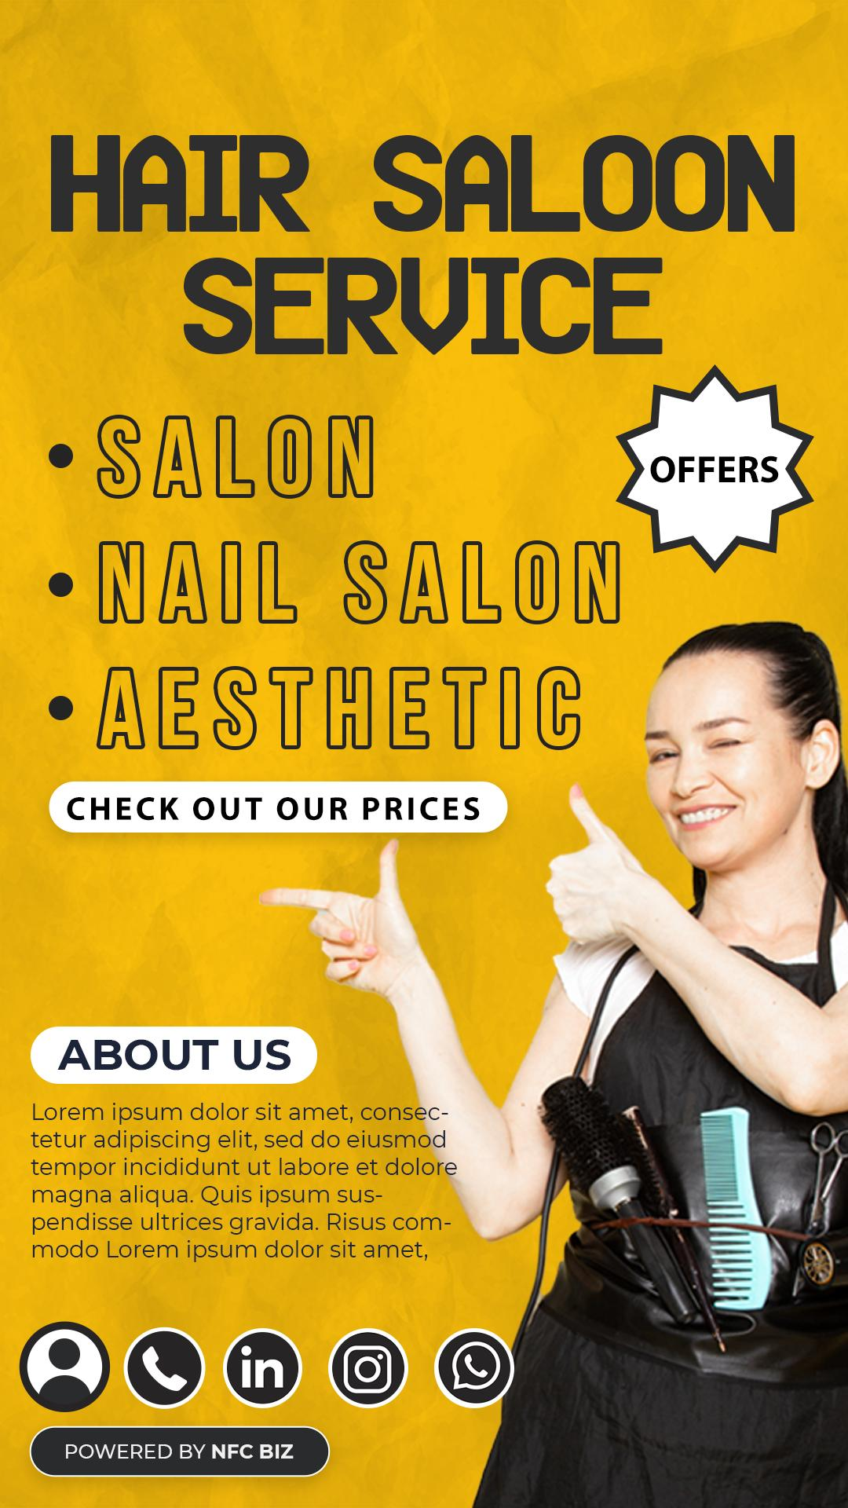

Background image - Upload image

Title - Heading

* Service 1
* Service 2
* Service 3

Link 1 - Link Text, URL

Link 2 - Link Text, URL

About us - Heading

About us - Description

Social Media Links

Instagram

Linked In

WhatsApp

Facebook

YouTube

TikTok

Twitter

Contact information -

→ Name

→ Email

→ Phone number

→ Address

Image - Upload image

**Phone Size 12: (business card)**

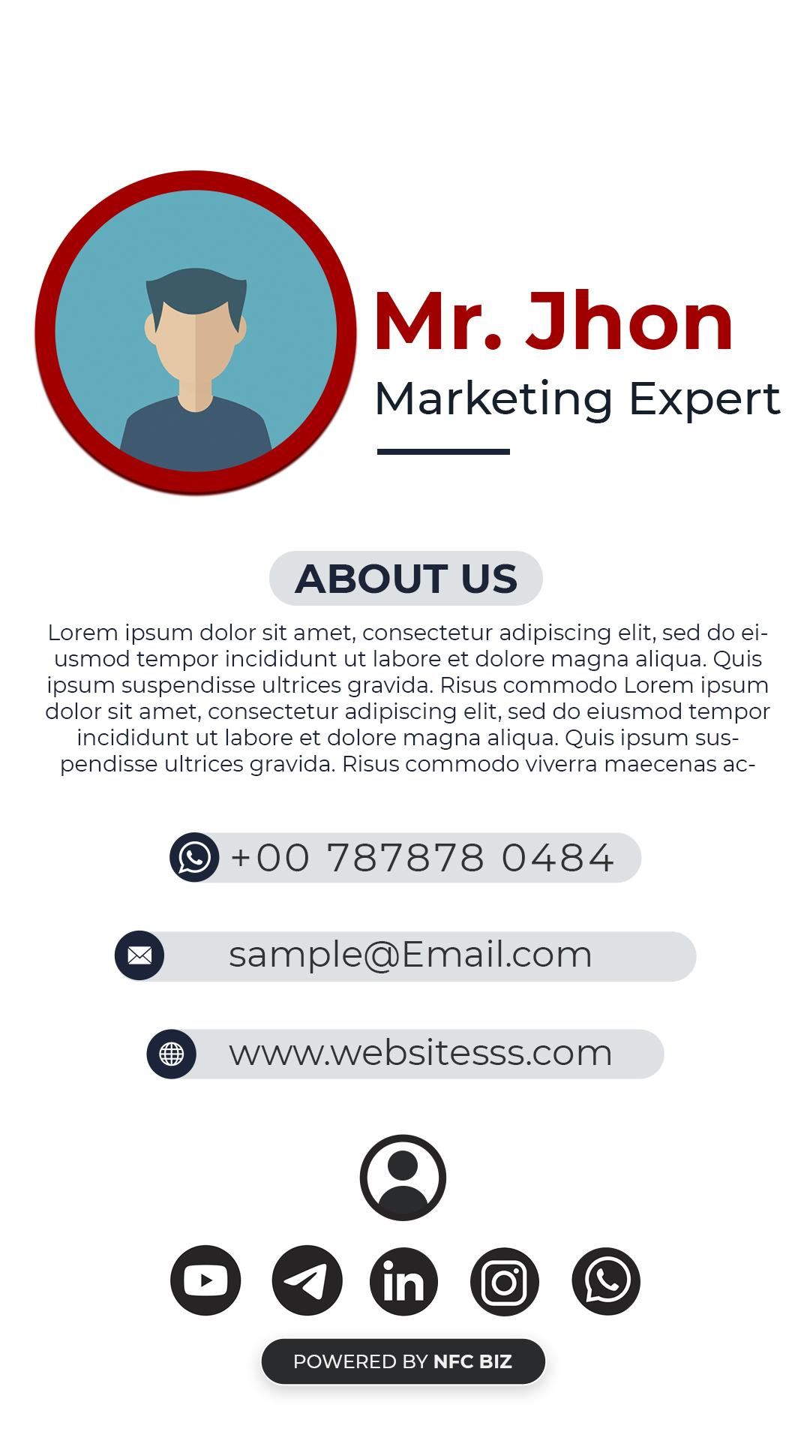

Background Image - Upload Image

Profile Image - Upload Image

Name

Occupation

About us - Heading

About us - Description

Phone Number

Email

Website

Social Media Links

Instagram

Linked In

WhatsApp

Facebook

YouTube

TikTok

Twitter

Contact information -

→ Name

→ Email

→ Phone number

→ Address

**Phone Size 14:**



Background Image - Image Upload

Title - Heading

Service 1 - Name

Service 2 - Name

Service 3 - Name

About us - Heading

About us - Description

Phone Number

Email

Website

Social Media Links

Instagram

Linked In

WhatsApp

Facebook

YouTube

TikTok

Twitter

Contact information -

→ Name

→ Email

→ Phone number

→ Address

**Phone Size 15:**

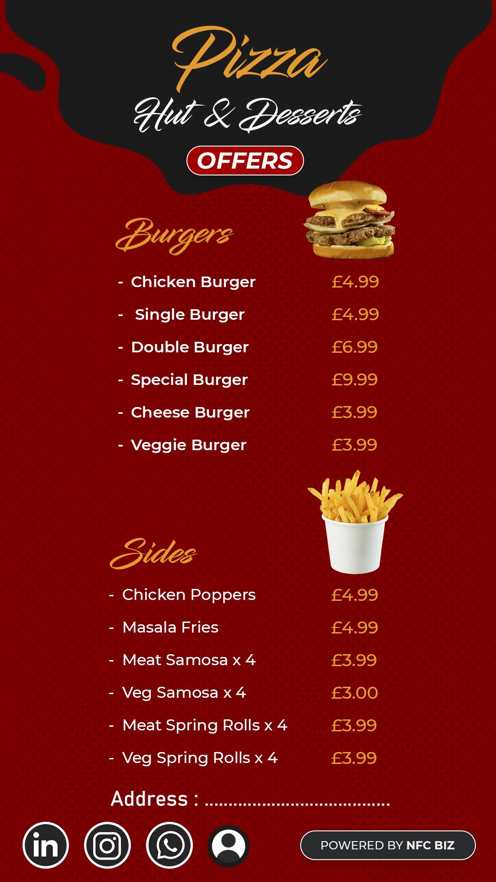

Background Image - Upload Image

Title - Heading

Subtitle

Heading 2

( The user should be able to add n number of categories to the list )

Item Category 1- Title

Image 1 - Upload image

Item 1 - Description & Price

Item 2 - Description & Price

Item 3 - Description & Price

Item 4 - Description & Price

Item 5 - Description & Price

Item Category 2- Title

Image 2 - Upload Image

Item 1 - Description & Price

Item 2 - Description & Price

Item 3 - Description & Price

Item 4 - Description & Price

Item 5 - Description & Price

Address - Location

Contact information -

→ Name

→ Email

→ Phone number

→ Address

Social Media Links

Instagram

Linked In

WhatsApp

Facebook

YouTube

TikTok

Twitter